FINAL REPORT
Experiment 4: OLAP Operations (Slice, Dice, Drill-up & Drill-down) using Microsoft Power BI

Objective
The objective of this experiment was to use Microsoft Power BI to analyze the Global Superstore data from different perspectives and levels of detail using OLAP operations.
Work Completed
In this experiment, we used the Global Superstore dataset and created an interactive Power BI report to analyze business performance. The report included information such as Sales by Region, Profit by Category, Sales by Segment, and Sales Trend by Year.
A Slice operation was performed by selecting a single region from the report. This allowed us to focus on the performance of one particular region and observe the corresponding changes in sales, profit, and orders.
A Dice operation was performed by applying multiple conditions at the same time, such as selecting a specific region, category, and year. This helped us analyze a smaller and more specific part of the dataset.
For Drill-down, a hierarchy of Region → State → City was used. We moved from a summarized regional view to more detailed state and city-level information. This helped us identify detailed sales patterns within different geographical areas.
For Drill-up, we moved back from the city level to the state and then region level. This allowed us to return to summarized information and compare overall performance with detailed results.
Final Outcome
The four OLAP operations were successfully implemented in Power BI. The report allowed the data to be viewed at different levels and from different perspectives. Slice and Dice helped filter the data, while Drill-down and Drill-up helped move between detailed and summarized information.
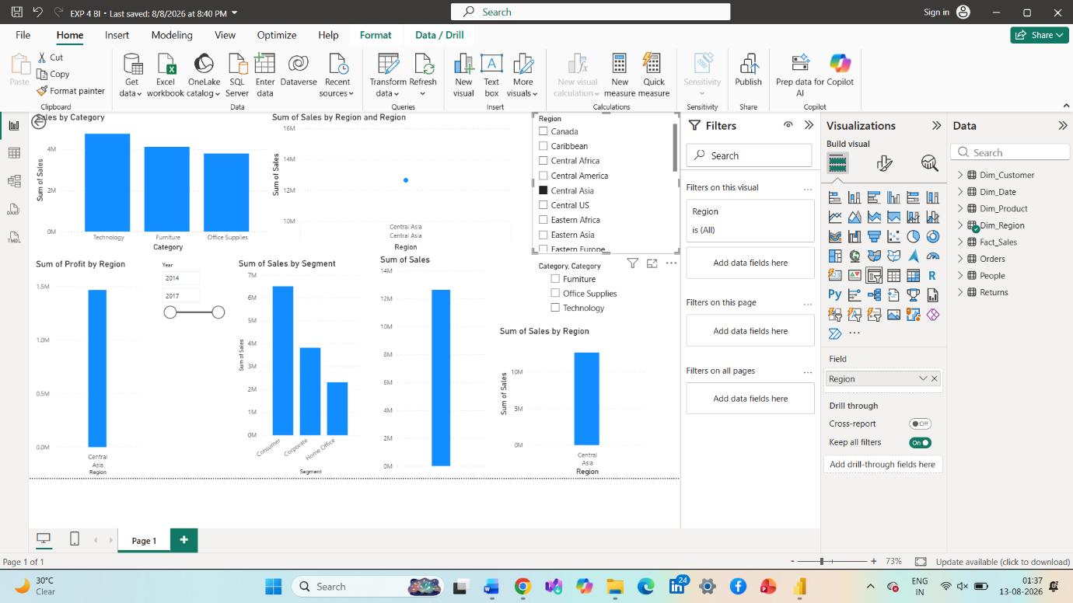
Conclusion
This experiment gave us practical experience with OLAP analysis in Power BI. We learned how interactive filters, slicers, and hierarchies can be used to explore business data efficiently. These operations make it easier to identify patterns, compare performance, and support better business decision-making.

